HESSIAN CORNER DETECTION

**APPLICATION OF LOCAL FEATURES**

**IMAGE MATCHING:**

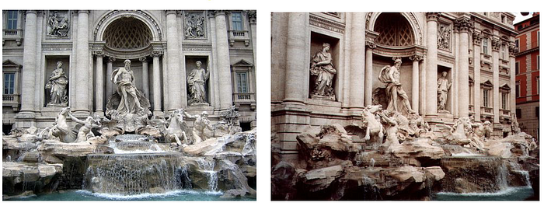

Local features are useful when it comes to performing the image matching tasks.One can extract local features from the pictures, and compare them. If their similarity is higher than a certain threshold, the two pictures are taken from the same tourist spot.

**IMAGE STITCHING**

Another application of local feature representations is Image stitching. Think of two images, which are of the same object but from different angles, that we want to combine them properly so that they become a one picture.

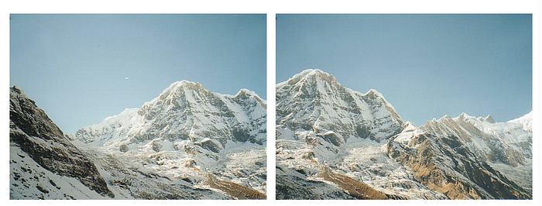

*Fig 3*is showing two images of a mountain and the task is to stitch them. To do this, we can begin with

* detecting feature points in both images, which are noted as white dots in the following figure.
* Then to find corresponding pairs of detected feature points.
* lastly, use the found pairs in order to align the images so that we obtain the final stitched image.

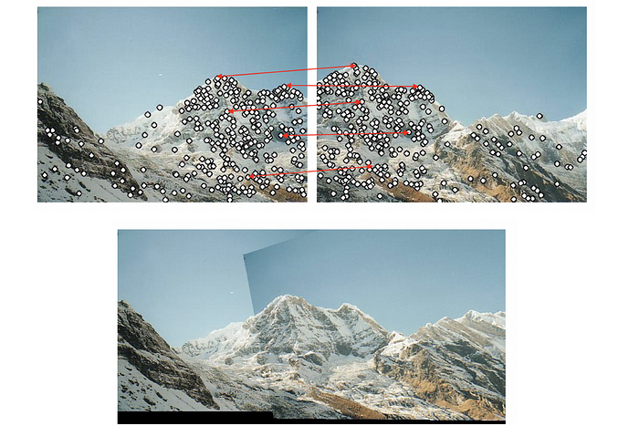

**APPROACH FOR IMAGE MATCHING AND STITCHING**

(1) Find distinctive key points from given images.

(2) Define a local region around each key point.

(3) Extract and normalize the region content.

(4) Compute a local descriptor for each normalized region using pixel information.

(5) Match the local descriptors between images.

**PROBLEM**

The defined local feature descriptors have two requirements to meet in order to successfully do their job.

* + The descriptor should detect the same keypoint independently in both images
  + For each point from one image, the descriptor should produce a reliable feature representation to find its corresponding key point in the other image.

If there is no key point pair found, then matching and stitching are impossible.

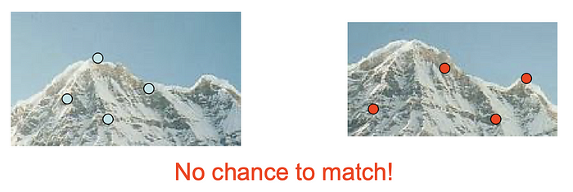**PROPERTIES OF KEY POINTS**

* should be repeatably detected
* should be precisely localized
* should contain interesting contents
* There are some types of keypoint that include the mentioned properties, like blobs and corners. We will see the detection of corners using Hessian Corner detection Algorithm.

**WHY CORNERS AS KEY POINT?**

Corners are the most distinctive key points for localization in images because they exhibit significant changes in pixel gradient when shifted in any direction. In contrast:

* Flat regions remain unchanged regardless of movement, making them unsuitable for key points.
* Edges show slight changes only when shifted along the pixel gradient, but this variation is weak.
* Corners, however, have strong gradient changes in all directions, making them ideal for accurate feature detection.

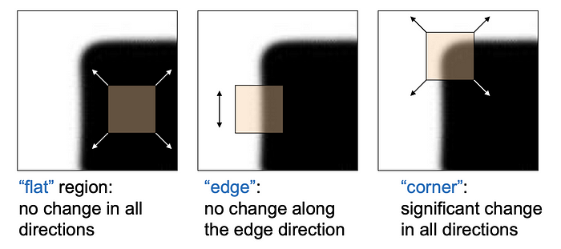

**HARRIS DETECTOR:**

The corners are regions with a large variation in intensity between pixels in all directions. The Harris detector measures the difference between the original pixel intensity and the intensity after shifting by some amount (u,v):

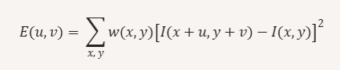

where I(x, y) is the intensity of a pixel and w(x, y) is the weighting function.

**WEIGHTING FUNCTION:**

The weighting function w(x,y) ensures that nearby pixels contribute more to the calculation than distant ones.

For example,

In a window around a corner, the central pixels have a larger impact on the computation due to the weighting function, making detection more precise.

The general formula for a first-order Taylor approximation of a function f(x) at x+u is:

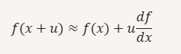

Applying this to image intensity I(x+u,y+v), we expand it around (x,y):



* Ix=∂I/∂x (gradient in x-direction)
* Iy=∂I/∂y(gradient in y-direction)

The expression simplifies to:



Replacing I(x+u,y+v) in the equation



After replacing:

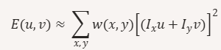

Expanding:



We express this in matrix form:



where M is the second moment matrix

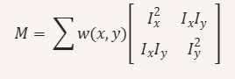

**HOW THE SECOND MOMENT MATRIX DETECTS THE CORNER?**

The second moment matrix M plays a crucial role in detecting corners by analyzing intensity variations in an image.



* In vertical edges, Iy=0 because pixel intensity does not change along the vertical direction.
* In horizontal edges, Ix=0 because intensity remains constant along the horizontal direction.
* In flat regions, both Ix and Iy are zero, meaning no intensity variation.

Since IxIy=0 in these cases, the matrix M becomes diagonal, meaning the non-diagonal elements vanish.

The matrix M can be diagonalized as:

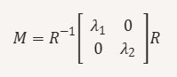

where:

* λ1 and λ2 are the eigenvalues of M.
* The eigenvalues represent the strength of intensity variations in different directions.
* The eigenvectors define the principal directions of intensity change.

**APPROACH FOR CORNER DETECTION**

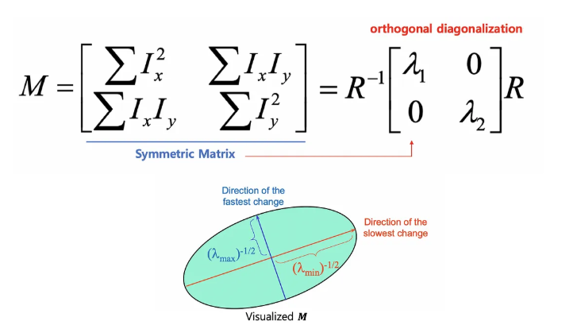

* If both eigenvalues are large, the pixel is a corner (strong variation in multiple directions).
* If one eigenvalue is large and the other is small, the pixel is an edge (variation in only one direction).
* If both eigenvalues are small, the pixel is in a flat region (no significant variation)

**CORNER RESPONSE FUNCTION**



* Corner: R>>0 → Strong variation in multiple directions.
* Edge: R≈0 but negative → Variation in only one direction.
* Flat Region: R≈0 approx 0 and small → No significant variation.

**HESSIAN DETECTOR**

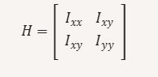



* The basic ideas of detecting corners remain the same as the Harris detector, the Hessian detector makes use of the Hessian matrix and determinant, instead of second-moment matrix M and corner response function R, respectively

The entries in the Hessian matrix are the second derivatives

**ROTATION INVARIENT**

* The second moment matrix M is symmetric, meaning it satisfies:



* A symmetric matrix can always be orthogonally diagonalized, meaning we can rotate the coordinate system to align with the principal directions of intensity change.
* This allows M to detect corners regardless of their orientation.

**NOT A SCALE INVARIENT**

* Once a corner gets magnified and becomes bigger than the size of the window by zooming, the Harris and Hessian can no longer detect the corner. It is because what the detectors perceive through the window is not a corner anymore but an edge due to the scale change.
* In order to overcome this limitation, a number of researches have been performed to create scale-invariant feature detectors.

**CONCLUSION:**

The Harris and Hessian Corner detection are used to detect the corner points which is used for many purposes like image stitching and matching. But when using the scaled image lead to the failure of these algorithms.